How to guide post template
Meta title  Character limit: 39/60 | How To Choose An Automatic Pool Cleaner In South Africa
Meta description  Character limit: 129/140 | Use these steps to find the right pool cleaner by exploring types of automatic pool cleaners, features & costs. Read on Baracuda
Focus keyphrase | - how to choose the right swimming pool cleaner  - swimming pool cleaner
Surfer credit | Linked. Terms:  - how to choose the right swimming pool cleaner  - swimming pool cleaner
Suggested URL (56/60) | https://baracuda.co.za/blog/how-to-choose-a-pool-cleaner
Keyword research sheet link | Budget How To Guide: How to Choose the Right Swimming Pool Cleaner
Image folder | How to choose the right swimming pool cleaner
Title and introduction

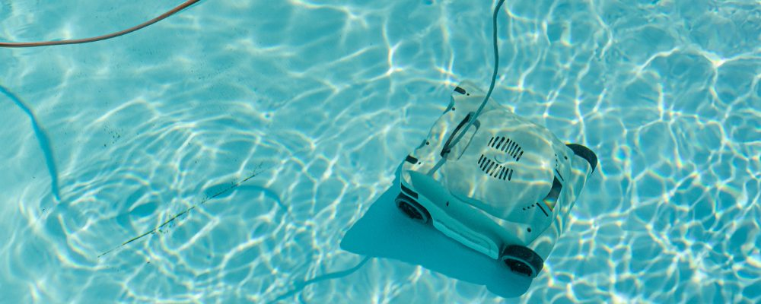

H1: How To Choose An Automatic Swimming Pool Cleaner In South Africa
<p> Finding the perfect automatic pool cleaner can transform your pool maintenance routine from a weekly chore into a stress-free effortless experience - so you can spend more time swimming and less time skimming and scrubbing!

Let us help you simplify the process of choosing the right swimming pool cleaner, whether you’re a new pool owner or looking to upgrade your existing setup.

This guide offers you steps to follow to find the right solution, including considerations related to your pool, your environment, the types of pool cleaners on the market (including their typical pricing) & much more.

By the end, you'll have all the information needed to make an informed decision that suits your budget and cleaning requirements.

Baracuda is trusted by pool owners across South Africa, offering a range of suction and robotic pool cleaners that combine cutting-edge technology with reliable performance. If you’re interested in purchasing one of our automatic pool cleaners, find a pool store near you that stocks Baracuda products.

Key takeaways
Key takeaways

- Assess your pool's size, surface type, and debris levels before comparing cleaner options and features. Suction cleaners work best on vinyl and fiberglass surfaces, while robotic models with strong brushes excel on concrete. Always check brush compatibility to protect your pool’s finish.
- Consider the types of devices available on the market, including suction, pressure and robotic pool cleaners. Take into account their functionality and smart features available.
- Consider your budget, including the initial purchase price as well as ongoing operating and maintenance costs.
- Other considerations include the brand you select, the availability of replacement parts, warranty coverage and support services.

Table of contents
H1: How To Choose The Right Swimming Pool Cleaner 1
H2: How Much Do Swimming Pool Cleaners Cost in South Africa? 3
H2: 8 Steps To Help You Find The Right Swimming Pool Cleaner 4
H3: Step 1: Consider your swimming pool’s size, shape & surface 4
H3: Step 2: Understand the environment surrounding your swimming pool & typical debris 5
H3: Step 3: Consider the time you have for daily/weekly upkeep 6
H3: Step 4: Understand types of swimming pool cleaners, their features & functionality 6
H3: Step 5: Consider the brand’s availability in South Africa, their reputation & support network 8
H3: Step 6: Part availability, warranty coverage & support 10
H3: Step 7: Set a realistic budget: Consider once-off and ongoing costs 10
H3: Step 8: Check with your pool store to see if demos are available 11
H2: Final Thoughts on How to Choose the Right Swimming Pool Cleaner 12

Value-add section

H2: How Much Do Automatic Swimming Pool Cleaners Cost in South Africa?

<p> The cost of automatic swimming pool cleaner prices in South Africa can vary significantly depending on the type, brand, and features you choose.
You can expect to pay anywhere from R900 for basic suction-side models up to R30,000 for premium robotic systems. Understanding this price range helps you set realistic expectations and find the best value within your budget.
Suction-side automatic cleaners represent the most affordable entry point, typically ranging from R900 to R8,000 for reliable models that connect to your existing filtration system.
Robotic pool cleaners command higher prices from R8,000 to R30,000+ due to their advanced automation, smart navigation, independent filtration systems, and superior cleaning capabilities.
However, don't focus solely on the initial purchase price.

Consider ongoing expenses, such as energy consumption, replacement parts, and regular maintenance, when planning your pool cleaner budget.

Investing in a quality swimming pool cleaner upfront typically saves both time and money on pool maintenance over the years, making it a smart long-term decision for most pool owners.

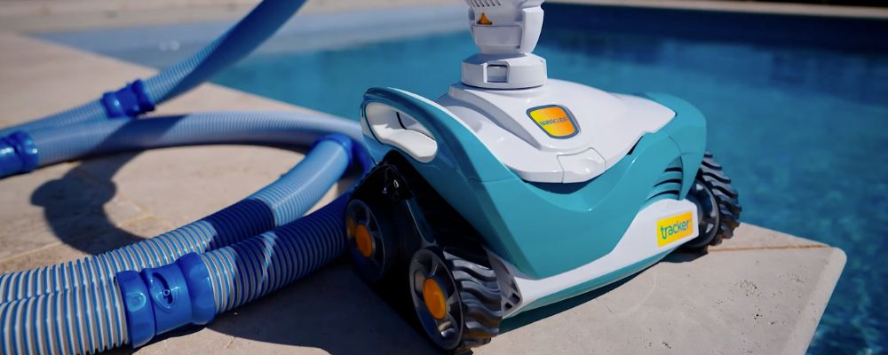

Steps to achieve the outcome

H2: 8 Steps To Help You Find The Right Swimming Pool Cleaner

<p> These steps will guide you through how to pick the right swimming pool cleaner.

We’ll take you through everything from assessing your pool’s shape, size and surface, to considering typical debris, the time you have for upkeep, types of pool cleaner models, budget considerations and more.

Read on to find practical tips and expert advice that will help you choose the ideal automatic cleaner for your residential swimming pool.

H3: Step 1: Consider your swimming pool’s size, shape & surface

Start by taking into account whether you have an in-ground pool or above-ground pool, as this determines which pool cleaners are compatible with your setup.
Pool size and shape also matter significantly. Larger pools (over 50m²) may require more powerful cleaners or models with longer cleaning cycles to ensure complete coverage.
Pool shape is equally crucial—rectangular and oval pools are easiest for most cleaners to navigate, while kidney-shaped, L-shaped, or freeform pools with curves and steps need cleaners with smart navigation and climbing capabilities to reach all areas effectively.
Pools with deep ends, shallow play areas, or multiple levels benefit from robotic cleaners that can handle varying depths.
Your pool's surface finish is also important and affects cleaner compatibility.
Vinyl liners require gentler brushes to avoid tears and punctures. Concrete and gunite surfaces can handle more aggressive scrubbing and stronger suction.
Fibreglass pools need cleaners specifically designed for smooth, non-porous surfaces. Pebblecrete and exposed aggregate finishes may require specialised brushes, while tiled surfaces need cleaners that won't damage grout lines.
Always check manufacturer compatibility guidelines or consult an expert at a trusted local pool store to ensure your chosen cleaner won't damage your pool's finish over time.
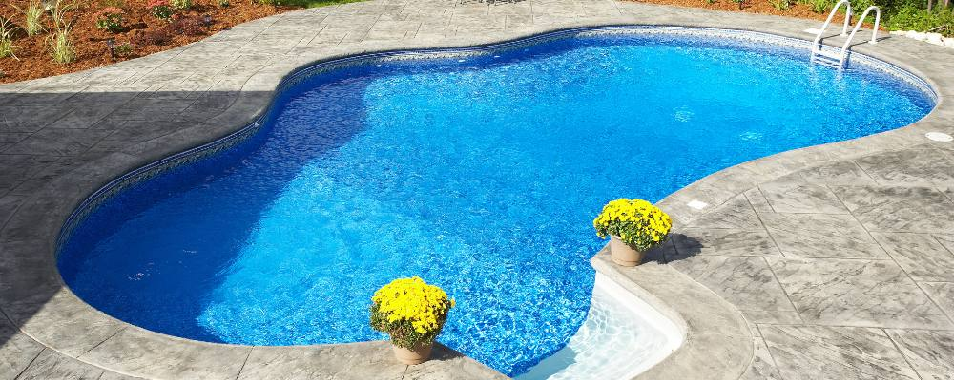

H3: Step 2: Understand the environment surrounding your swimming pool & typical debris

Your pool's surroundings directly impact the type and amount of debris you'll need to handle.

Pools surrounded by trees face constant leaves, twigs, and organic matter, requiring cleaners with large debris capacity and strong suction power.

In addition, depending on your surrounding environment, specialised filtration that can clear fine sand and dust might be important, or you may just need to filter out larger debris like grass clippings and flower petals.

Some swimming pool cleaners excel at picking up big items but struggle with fine debris, while others are designed specifically for small particles.

Understanding the debris commonly found in your pool helps you choose a cleaner with the right filter capacity and suction strength for your environment.

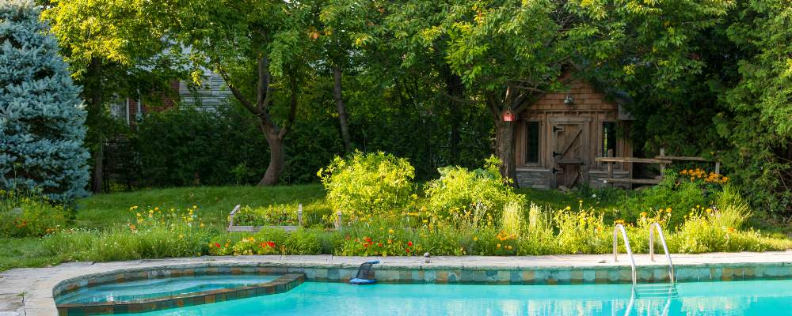

H3: Step 3: Consider the time you have for daily/weekly upkeep

Think about how much effort you're willing to put into pool cleaning. Your lifestyle and schedule can be key factors when choosing an automatic swimming pool cleaner.
Suction pool cleaners connect directly to your pool’s filtration system and offer a hands-free way to maintain your pool. They move automatically and are great for routine maintenance, though they may occasionally need repositioning or clearing from tight corners.
Robotic pool cleaners take convenience to the next level. These advanced units operate completely independently, using built-in filtration and smart navigation to deliver a thorough clean with minimal supervision. Just drop it in, press start, and let it take care of the rest—no hoses, no manual effort.
Baracuda offers both suction and robotic pool cleaners designed to suit your schedule, budget, and pool type. Find the right fit for your needs—use our interactive map to find a pool store that stocks Baracuda products near you.
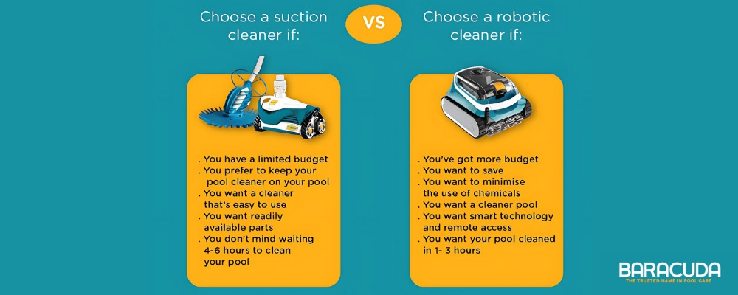

H3: Step 4: Understand types of swimming pool cleaners, their features & functionality

Now that you understand your pool's requirements, it's time to explore the types of automatic swimming pool cleaners available on the market.

Each type of pool cleaner operates differently and offers distinct advantages depending on your budget, preferences, and cleaning needs.

Understanding how these systems work will help you determine which technology best suits your pool.

- Suction-Side Pool Cleaners: Suction-side cleaners connect to your pool's skimmer or dedicated suction line, using your filtration system's pump to create movement and suction. They're cost-effective, easy to install, and work well for most types of debris. However, they can put additional strain on your pool's filter system, when compared to robotic pool cleaners, and may require frequent filter cleaning during heavy debris seasons.

- Pressure-Side Pool Cleaners: These cleaners use water pressure from your pool's return jets to propel themselves around the pool while collecting debris in their own filter bags. They don't rely on your main filtration system and can handle larger debris effectively. Most require a dedicated booster pump for optimal performance, which increases installation complexity and energy costs.

- Robotic Pool Cleaners: Robotic cleaners are self-contained units with their own filtration systems, motors, and smart navigation. They operate independently of your pool's filtration system and connect to a low-voltage power supply unit, which plugs into a standard outdoor electrical socket. While requiring the highest upfront investment, they're the most energy-efficient and thorough cleaning option available.

H4: Look for Smart Features That Make Cleaning Easier
Modern automatic pool cleaners come with various smart features designed to take the hassle out of pool maintenance. When comparing models, look for these key features that can enhance your cleaning experience:
- Programmable cleaning cycles - Set daily, weekly, or custom schedules so your pool stays clean automatically, even when you're away
- Smart navigation systems - Advanced mapping technology ensures complete pool coverage and prevents cleaners from getting stuck in corners
- Multiple cleaning modes - Options like quick clean, deep clean, or spot cleaning let you customise based on your pool's current needs
- Smartphone app connectivity - Monitor cleaning progress, adjust settings, and receive maintenance alerts remotely from your phone
- Energy-efficient motors - Variable speed controls and optimised power consumption reduce electricity costs while maintaining cleaning performance
- Large debris capacity - Oversized filter bags or cartridges mean less frequent emptying during heavy debris seasons
- Climbing ability - Advanced models can clean walls and water lines, not just the pool floor
- Anti-tangle technology - Swivel connections and smart cord management prevent hose tangling and improve maneuverability
- Filter indicator alerts - Notifications when filters need cleaning or replacement help maintain optimal performance
- Quick-release mechanisms - Tool-free access to filters and parts makes routine maintenance faster and easier
These features can significantly reduce the time and effort required for pool maintenance, letting you focus on enjoying your pool rather than cleaning it.
Whatever your preference—cost-effective suction or fully automated robotic—Baracuda offers high-quality, reliable options trusted by South African pool owners. Use our store locator to find a nearby pool store that stocks Baracuda products.
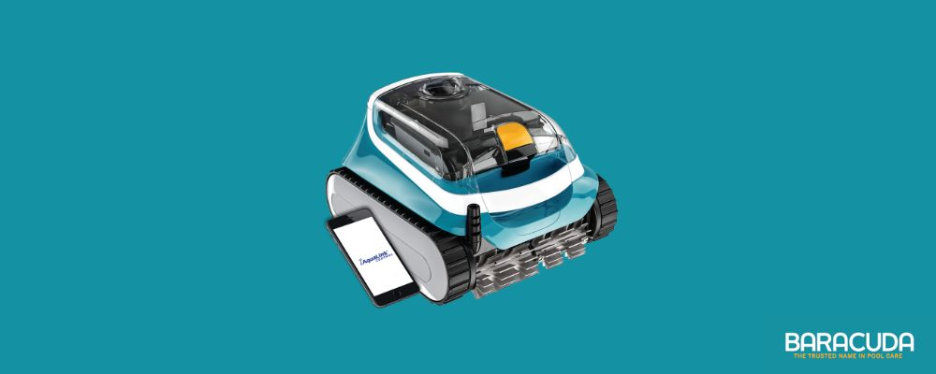

H3: Step 5: Consider the brand’s availability in South Africa, their reputation & support network
<p> Brand reputation matters significantly when investing in a pool cleaner.
Established manufacturers offer superior product support, reliable warranty coverage, and proven track records that give you confidence in your purchase.
The pool cleaner market features several trusted names, each with distinct strengths and specialties. Explore each brand below to understand their positioning and product offerings.

H4: Baracuda
Invented in 1976 by Helmut Hofman, Baracuda pioneered automatic pool cleaning with innovative diaphragm technology that delivered quieter operation and greater maneuverability—technology still used in modern disc suction cleaners today. Offering models like the Ranger, Tracker, XA2030, and XA4030 iQ, Baracuda maintains its founding principles of excellent quality products that remain affordable and simple to install, use, and maintain.

H4: Zodiac
Globally recognized as one of the most trusted names in pool care, Zodiac offers high-performance equipment designed to create enjoyment and peace of mind for pool owners worldwide. Their popular models include the G3, MX6, MX8, and T5 Duo, known for reliable performance across various pool types. Both Baracuda and Zodiac operate under Fluidra, combining decades of innovation with extensive international support networks.

H4: Dolphin (Maytronics)
Since 1983, Maytronics has led robotic pool cleaning innovation under their Dolphin brand. Recognized for intelligent navigation and energy-efficient designs, models like the Nautilus CC Plus, S200, and M500 represent premium automated pool care. Their focus on smart technology and minimal maintenance appeals to tech-savvy pool owners wanting cutting-edge performance.

H4: Kreepy Krauly
A South African pool cleaning pioneer since 1974, Kreepy Krauly developed innovative hydraulic suction technology and became a household name nationwide. Now part of Pentair, their proven models including the Classic Kreepy Krauly, Dominator Pro, and Bull Shark Pro are known for reliable performance and simple maintenance. With over 90 warranty stations across South Africa, they provide exceptional local support for pool owners.
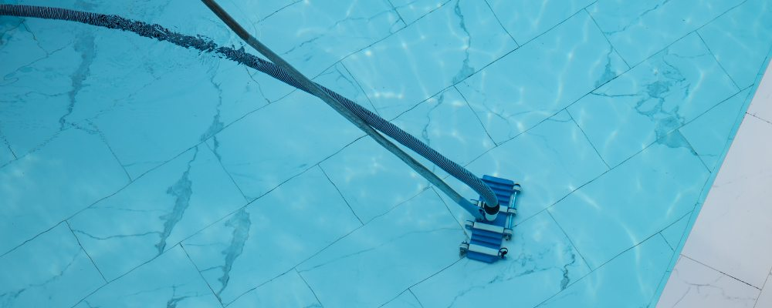

H3: Step 6: Part availability, warranty coverage & support
Reliable after-sales support and parts availability are crucial factors that many buyers overlook until problems arise.
Choose brands and pool stores that offer comprehensive warranty coverage, trained service technicians, and readily available replacement parts.
Pool cleaners with hard-to-find components can become expensive paperweights when simple repairs are needed.
Local support networks are important—brands with established South African presence typically offer faster service, competitive parts pricing, and technicians familiar with local pool conditions.
This support infrastructure can mean the difference between a quick repair and an extended period without pool cleaning.

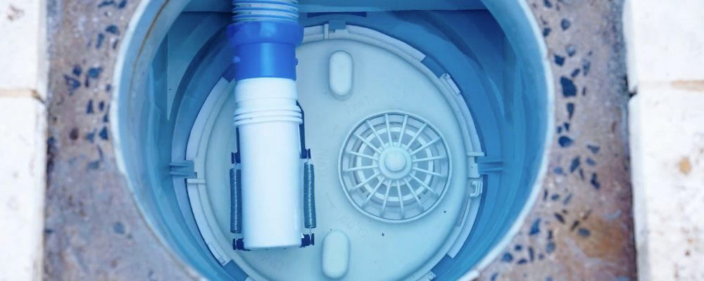

H3: Step 7: Set a realistic budget: Consider once-off and ongoing costs
Choosing the right pool cleaner isn’t just about the purchase price—it’s about finding long-term value that aligns with your pool’s needs and your maintenance habits.
Suction-side cleaners typically range from R900 to R8,000, making them a cost-effective choice for everyday cleaning. They’re ideal for lighter debris loads and are especially well-suited to smaller residential pools. Their simple, durable design keeps upfront costs low while offering reliable performance with minimal setup.
Robotic cleaners, priced between R8,000 and R30,000+, offer advanced features like smart navigation, programmable cleaning cycles, and independent filtration. They excel in larger pools, complex shapes, or areas with frequent debris, delivering precision cleaning with minimal oversight. While the initial investment is higher, many homeowners find the convenience and efficiency well worth it over time.
When budgeting, it’s also important to consider ongoing costs such as:
- Electricity usage: Robotic cleaners are energy-efficient and typically cost less to run than a pool pump operating a suction cleaner for several hours.
- Wear and tear: Suction cleaners use your pool’s filtration system, which can lead to increased filter cleaning or replacement, especially during high-debris seasons.
- Replacement parts: Both types may require periodic replacement of hoses, tracks, or diaphragms. Choosing a reputable brand like Baracuda ensures easy access to genuine spares and reliable after-sales service.
Whether you prioritise affordability and simplicity or cutting-edge automation, both suction and robotic cleaners offer excellent long-term value when matched to the right pool and usage needs.
Use our store locator to find a nearby pool store that stocks trusted Baracuda products and get expert advice on the best cleaner for your pool and budget.


H3: Step 8: Check with your pool store to see if demos are available
Before making your final decision, ask your local pool store if they offer a product demonstration. Whether it’s an in-store setup or a poolside trial, seeing a cleaner in action is one of the best ways to understand how it performs.
A demo allows you to:
- Observe how the cleaner moves and navigates different surfaces
- Compare suction or robotic models based on real cleaning performance.
- Assess ease of use, from setup to maintenance.
- Ask questions specific to your pool size, shape, or debris challenges
Most reputable pool shops are happy to walk you through the key features or arrange a trial to help you feel confident in your choice—especially for higher-end robotic models.
Use our interactive map to find a pool store near you that stocks Baracuda products and ask them whether they can offer demos or other personalised advice to help you make an informed decision.
Conclusion

H2: Final Thoughts on How to Choose the Right Swimming Pool Cleaner
<p> Choosing the right swimming pool cleaner doesn't have to be overwhelming when you break it down into manageable steps.
You now have a clear roadmap for assessing your pool's needs, understanding cleaner technologies, evaluating brands, and setting a realistic budget.
Here are two quick steps to help you get started:
First, identify your pool type, size, and surface material—this eliminates unsuitable cleaners immediately.
Second, explore Baracuda's range of swimming pool cleaners to see which models align with your requirements and budget.
For deeper insights, explore Baracuda's swimming pool tips and guides..
We cover everything from how a pool pump works and how long you should run your pool pump for, and how to increase pool circulation to guides to suction pool cleaners, weekly pool maintenance, and much more.
Baracuda offers a complete range of automatic pool cleaners, including efficient suction-side models designed for residential and spa pools and to suit most surface types and sizes, like our popular Ranger and Tracker cleaners. Plus our advanced robotic pool cleaners, such as the XA2030 and XA4030 iQ provide effortless cleaning with smart features and navigation that simplify pool cleaning. Use our interactive map to find a pool store near you that stocks our products, or reach out to us directly for advice.

